**

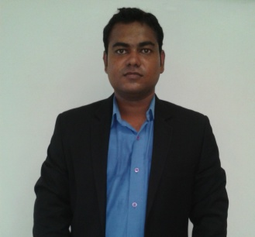

ABHAY SINGH  
IMS HOSTEL ROOM NO -317  
GHAZIABAD, Uttar Pradesh -201001  
abhayk466@gmail.com  
09582838531

**CAREER OBJECTIVE**

Seeking a career to utilize my knowledge, personal skills to gain comprehensive understanding at a reputed organization so as to take responsibility and contribute significantly.

**PROFESSIONAL SKILL**

**Organization :** Lumibini beverages pvt.ltd.  
**Duration :** 8 weeks  
**Project :** A study about sales and promotion of Pepsi.

* What is the impact of promotional strategies used by Pepsi.
* To study the distribution process of pepsi.

**EDUCATIONAL QUALIFICATION**

|  |  |  |  |  |
| --- | --- | --- | --- | --- |
| **YEAR** | **DEGREE** | **PERCENTAGE** | **INSTITUTE** | **UNIVERSITY** |
| 2012-14 | PGDM (Marketing & H.R) | 6.48(CGPA) | IMS Ghaziabad | AICTE |
| 2008-2011 | B.A.(Honrs) | 55.75% | A.N. College | Magadh University |
| 2008 | 12TH | 63% | S.M. Inter college | U.P. Board |
| 2006 | 10TH | 67% | S.M.Inter college | U.P. Board |

**PROFESSIONAL SKILLS**

* MS OFFICE
* Diploma in Computer Application

**LIVE PROJECT**

* 6 day at Big Bazaar as Professional Exposure.

**INDUSTRIAL VISIT**

* One day industrial visit to “Parle agro Neemrana” (2012).
* One day industrial visit to “Mother dairy Patparganj” New Delhi (2012).
* One day industrial visit to “Yakult plant Sonipat” Haryana (2013)

**EXTRA-CURRICULAR ACTIVITY**

* Coordinator for National Conference in IMS, GHAZIABAD.
* Participated in singing competition in college fest.

**HOBBIES**

* Singing
* Playing Cricket
* Driving

**KEY ATTRIBUTES**

* Team Player and Leadership qualities
* **Responsible**
* Quick learner

**PERSONAL DETAILS**

Date of Birth : 15-05-1990

Gender : Male

Marital Status : Single

Permanent Address : Vill.-KHARADRA, Po.- KANDHPAKER, Ps.-ASSON

Dist.-SIWAN, PINcode.-841287,(BIHAR)

**DECLARATION**

I hereby declare that the information furnished above is true to the best of my knowledge and belief.

**Place**: Ghaziabad (ABHAY SINGH)